EXAMPLE

8

9

7

2

4

5

8

6

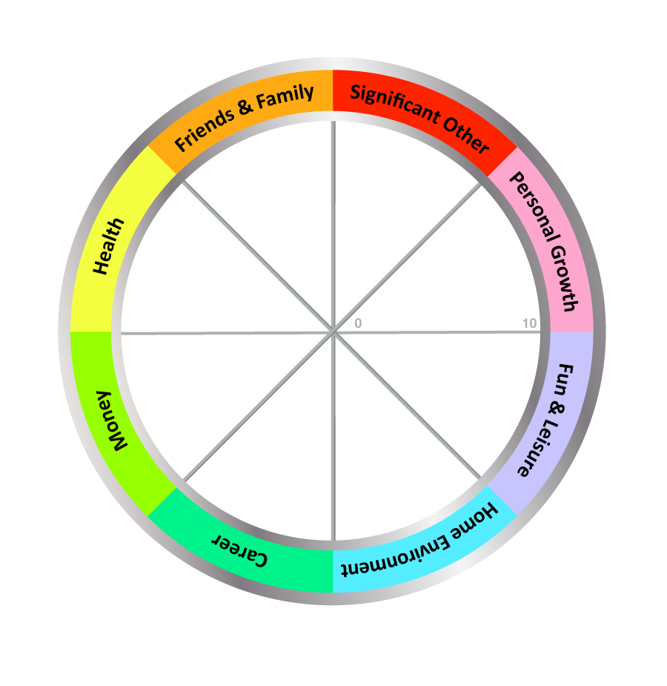
YOUR NAME: __________________________________

TODAY'S DATE: ____________________

COMPLETE THE WHEEL:

1. Review the 8 Wheel Categories - think briefly what a satisfying life might look like for you in each area.

2. Next, draw a line across each segment that represents your satisfaction score for each area.

- Imagine the centre of the wheel is 0 and the outer edge is 10
- Choose a value between 1 (very dissatisfied) and 10 (fully satisfied)
- Now draw a line and write the score alongside (see example above)

IMPORTANT: Use the FIRST number (score) that pops into your head, not the number you think it should be!

